| **Test Name** | | Add error to system | | | |
| --- | --- | --- | --- | --- | --- |
| **Use Case Tested:** | | Use Case 1 – Add Error to System – Physician Advised | | | |
| **Test Description:** | | User:   * Enters the date the error occurred * Enters the time the error occurred * Enters the patient MRN (hospital ID for patient) * Enters the patient’s first name * Enters the patient’s surname * Selects the patient type * Selects the error type * Enters name of medication * Selects medication type * Enters a description/comment * Selects the person who made the error * Selects if person making error has been notified * Selects where error was detected * Selects if IIMS was completed * Selects the severity level * Selects if physician was notified (Yes) * Enters Physician provider number * Enters Physician first name * Enters Physician surname * Enters Physician comments * Enters Patient diagnosis * Selects Submit button | | | |
| **Pre-conditions** | | User has successfully logged in.  Enter an Error page is presented to user | | | |
| **Post-conditions** | | When Physician Advised field is selected as YES, following fields are enabled for data input  Database is successfully updated with the data on selection of Submit button | | | |
| **Notes:** | |  | | | |
| **Result (Pass/Fail/Warning/Incomplete)** | |  | | | |
|  | **TEST STEP** | | **EXPECTED TEST RESULTS** | P | F |
|  | Date is entered | | Date is accepted | P |  |
|  | Time is entered | | Time is accepted | P |  |
|  | Patient MRN is entered | | Patient MRN is not found in database and is accepted | P |  |
|  | Patient first name is entered | | Patient first name is accepted | P |  |
|  | Patient surname is entered | | Patient surname is accepted | P |  |
|  | Patient type is selected | | Selection accepted | P |  |
|  | Error type is selected | | Selection accepted | P |  |
|  | Medication entered | | Medication is accepted | P |  |
|  | Medication type is selected | | Selection accepted | P |  |
|  | Error description/comment is entered | | Error description/comment is accepted | P |  |
|  | Person making error is selected | | Selection accepted | P |  |
|  | Person making error notified selected | | Selection accepted | P |  |
|  | Where error detected selected | | Selection accepted | P |  |
|  | IIMS completed selected | | Selection accepted | P |  |
|  | Severity level is selected | | Selection accepted | P |  |
|  | Physician notified – Yes is selected | | Selection accepted and following fields are enabled | P |  |
|  | Physician provider number is entered | | Physician provider number is accepted | P |  |
|  | Physician first name is entered | | Physician first name is accepted | P |  |
|  | Physician surname is entered | | Physician surname is accepted | P |  |
|  | Physician comments are entered | | Physician comments are accepted | P |  |
|  | Patient diagnosis is entered | | Patient diagnosis is accepted | P |  |
|  | User selects Submit button | | Database updated with data as entered above | P |  |

|  |  |  |  |  |  |
| --- | --- | --- | --- | --- | --- |
| **Test Data Table** | | | | | |
|  | **1** | **2** | **3** | **4** | **5** |
| Date: | 2018-05-12 |  |  |  |  |
| Time: | 04:07 |  |  |  |  |
| Patient MRN: | Hidh980j |  |  |  |  |
| Patient First Name | George |  |  |  |  |
| Patient Surname | Hogan |  |  |  |  |
| Patient Type: | Inpatient |  |  |  |  |
| Error Type: | Incorrect Patient |  |  |  |  |
| Medication: | Morphine |  |  |  |  |
| Medication Type: | Intravenous |  |  |  |  |
| Error Description/Comment: | Medication was not given to patient |  |  |  |  |
| Person Making Error | Amanda Stait |  |  |  |  |
| Person Making Error Notified: | Yes |  |  |  |  |
| Where Error was Detected: | On the ward |  |  |  |  |
| IIMS Completed: | Yes |  |  |  |  |
| Severity Level | Severe |  |  |  |  |
| Physician Notified: | Yes |  |  |  |  |
| Physician Provider Number: | Jdin0958 |  |  |  |  |
| Physician First Name: | Mica |  |  |  |  |
| Physician Surname: | Norman |  |  |  |  |
| Physician comments: | Talked to staff member |  |  |  |  |
| Patient Diagnosis: | Not required |  |  |  |  |

SCREENSHOTS OF TEST

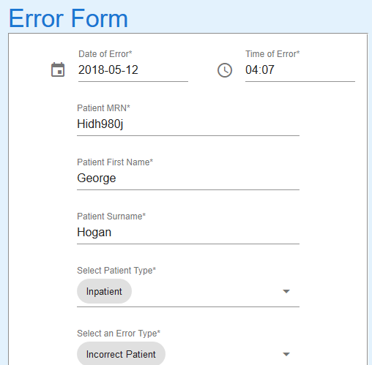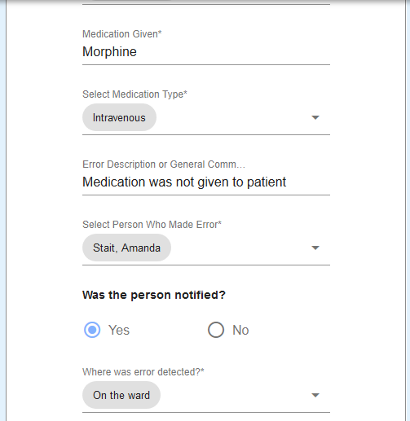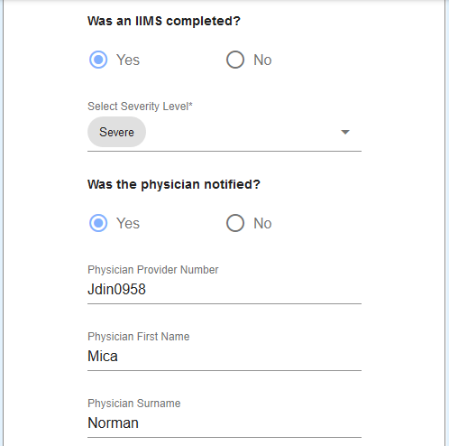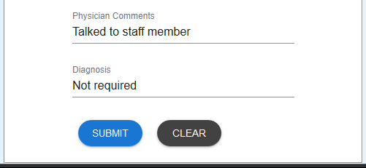

Details entered – All fields accepted

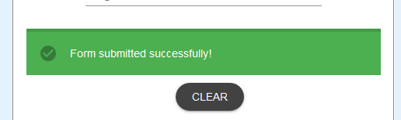

Data accepted

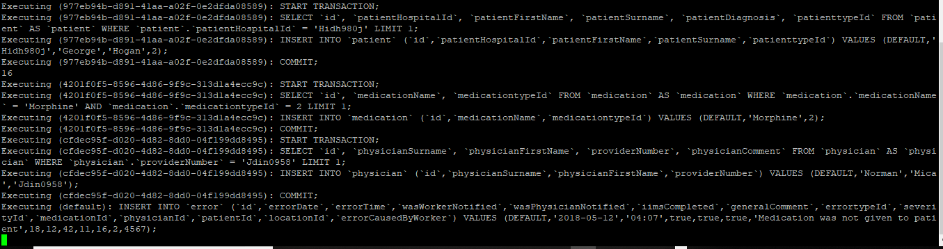

Query executed on server

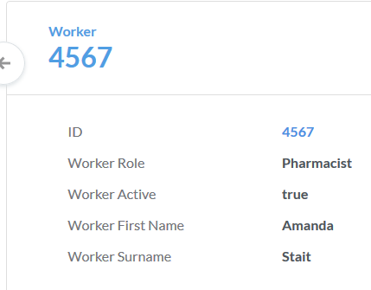

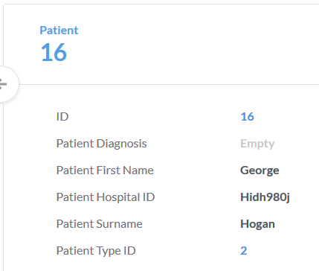

Data extracted from Metabase – List of Errors